Department of Romance Languages
University of Georgia
Spring 2015
Cinecittà 7
MARCELLO MASTROIANNI
(The movies are in Italian with English subtitles and suited for the general public. They will be shown in the Miller Learning Center, Room 148 at 7:00 p.m. every Tuesday.)

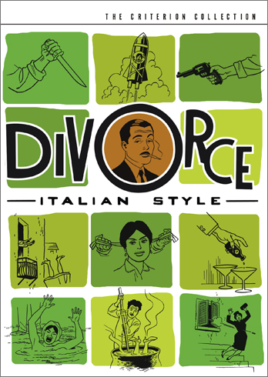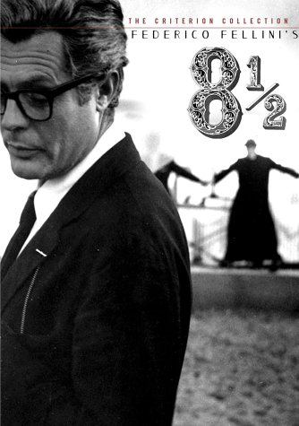

Divorzio all’italiana (1961) by Pietro Germi 8 ½ (1963) by Federico Fellini
February 24 at 7:00 pm (105 min) March 3 at 7:00 (138 min)

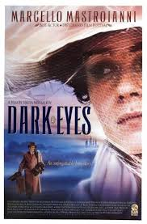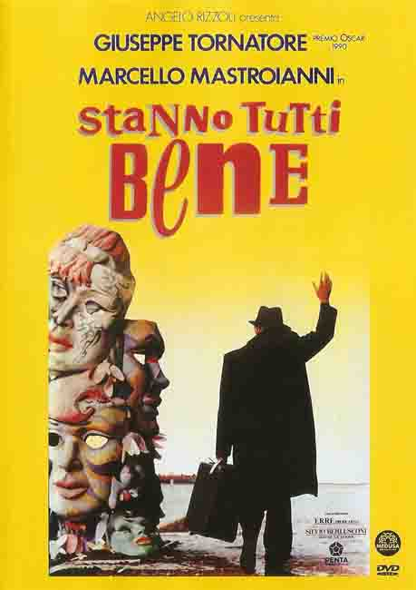

Oci Ciornie (1987) by Nikita Michalkov Stanno tutti bene (1991) by Giuseppe Tornatore
March 17, at 7:00pm (117 min) March 24 at 7:00 (120 min)

